BÀI 3 LÝ THUYẾT

Thiết lập IP tĩnh cho Domain Controller

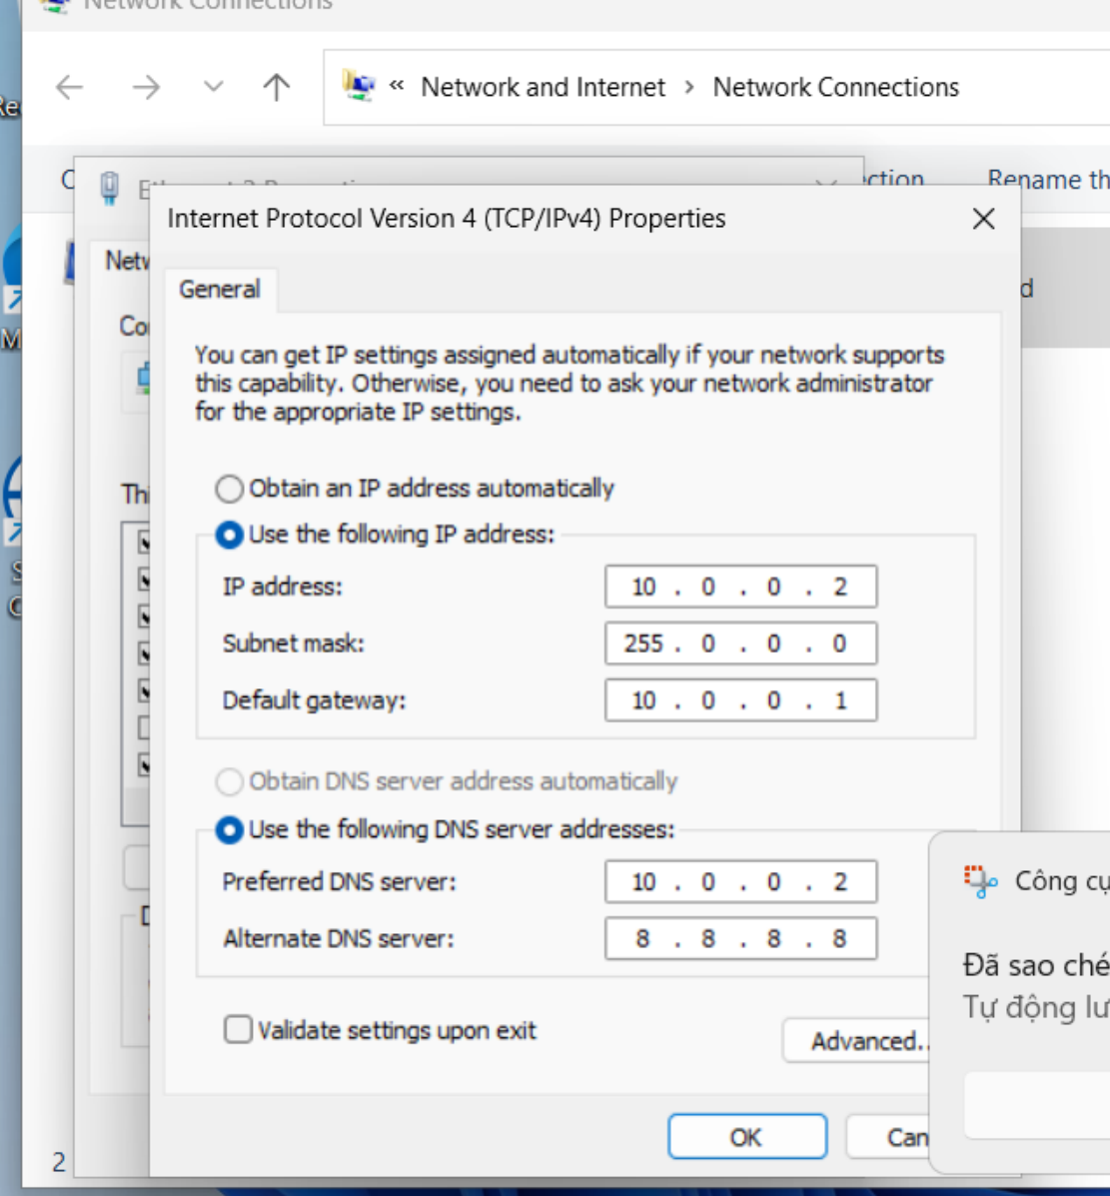

Đặt tên miền DNS

